CASE 1: A 76-year-old Spanish speaking male presents to LHM to establish care. A1C obtained 2 weeks prior by his nephrologist was 9.3%. He has been prescribed a number of pills for his diabetes but is not sure which ones he actually has at home.
- Which classes of diabetes medications have been prescribed to this patient?
- Which, if any, of his existing diabetes medications would you continue?
  - Is there any additional information you need?
  - For each medication you are considering, how would you counsel him on risks/benefits?
- Are there any additional classes of medications that you would consider for treatment of his diabetes?
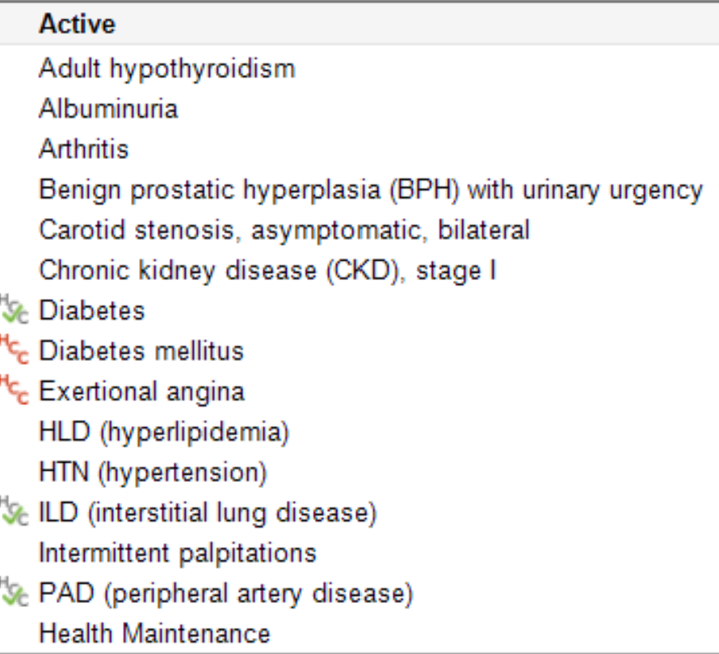

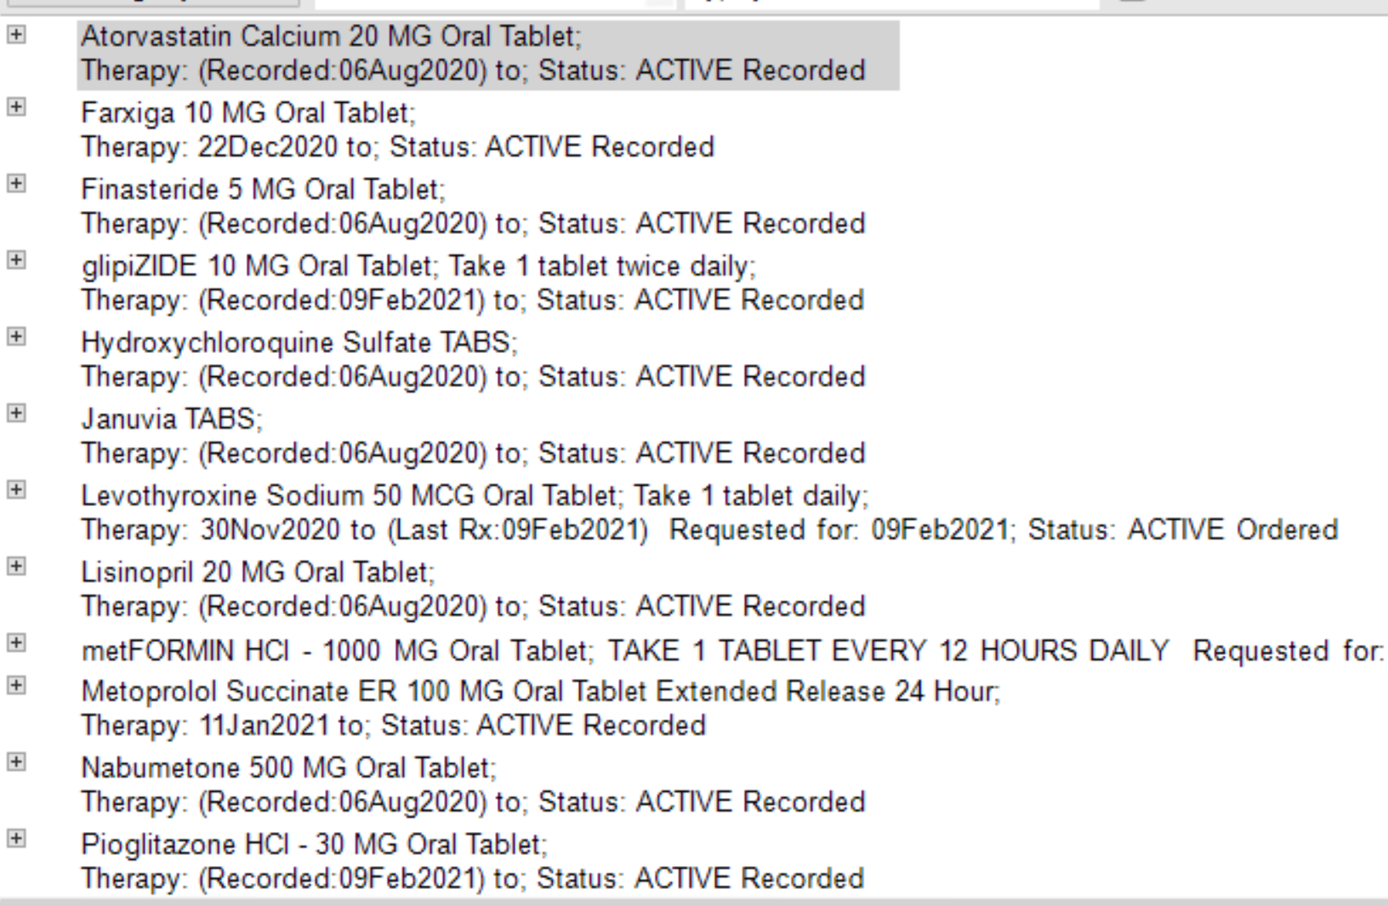
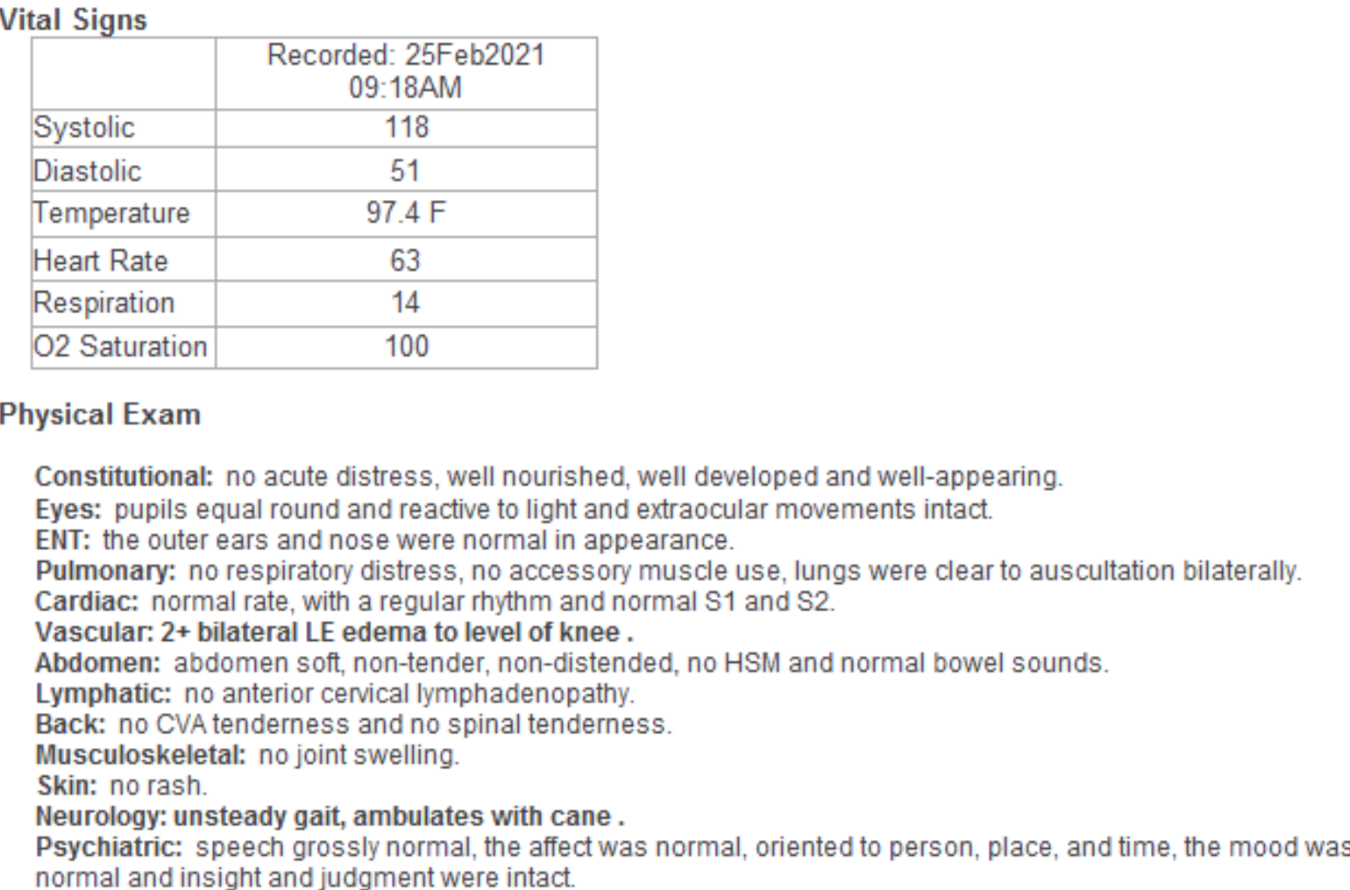

Case 2: A 70 year old female with diabetes presents for follow up. Her most recent A1C was 8.3%. Her problem list, vital signs and medication list are on the following page.
- What classes of medication is she currently taking for diabetes?
- Would you recommend any changes to her current regimen?
